IST370

Worksheet

**Chapter 9 – Part 1 (Simple Joins)**

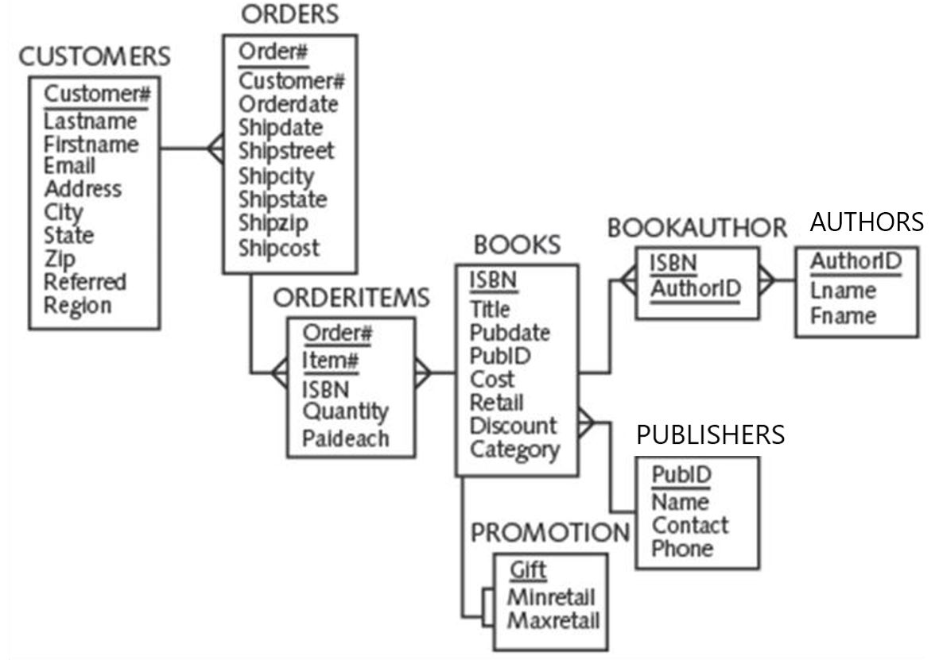

SELECT orders.order#, orderdate, quantity

FROM orders, orderitems

WHERE orders.order# =orderitems.order#;

**Practice 1: Write a query to address the following user request.**

Create a list displaying the title of each book, along with the publisher’s name and phone number of the contact at the publisher‘s office. Sort the result in ascending order of book title.

**Question:**

1. **What tables should be included in the FROM clause? Books and publishers**
2. **Which columns in the associated tables are so-called common (i.e. join) columns?**

**Pubid**

1. **How do you perform the join operation?**
2. **How do "qualify" the common columns?**

|  |  |
| --- | --- |
| **Input SQL Code** | **(Partial) Query Output:** |
| SELECT title, contact, phone  FROM books, publishers  WHERE publishers.pubid = books.pubid  ORDER BY title; | …. |

**Practice 2:**

**Type in the following query. You will be prompted with an error message. Why? How do you fix the error?**

SELECT title, pubid, name

FROM books, publishers

WHERE books.pubid = publishers.pubid;

Correction:

SELECT title, publishers.pubid, name

FROM books, publishers

WHERE books.pubid = publishers.pubid;

OR

SELECT title, books.pubid, name

FROM books, publishers

WHERE books.pubid = publishers.pubid;

**Questions:**

**1. Which columns in the query must be qualified? COMMON COLUMN(S)**

**2. Is it optional to qualify the 'non-common' columns? TRUE or FALSE**

**Practice 3: Examine the following query**

SELECT b.title, b.pubid, p.name

FROM books b, publishers p

WHERE b.pubid = p.pubid;

**Questions:**

1. **Are table aliases used in the query above? What are they?**
2. **Why use table aliases?**
3. **Once a table alias is defined for a particular table name in the FROM clause, the defined table alias must be used as a substitute for the table name throughout the entire SELECT statement. Is it true?**
4. **The table alias is valid only for the current SELECT statement. In a different SELECT statement, the table aliases need to be redefined. Is it true?**

**Practice 4:**

**Type in the following query. You will be prompted with an error message. Why? How do you fix the error?**

SELECT books.title, books.pubid, p.name

FROM books b, publishers p

WHERE b.pubid = p.pubid;

**Practice 5:**

Create a list that displays customer name, order#, order date, and ship date. Display only those orders that were placed in April, 2015. Sort the result in ascending order of order date.

Desired Output

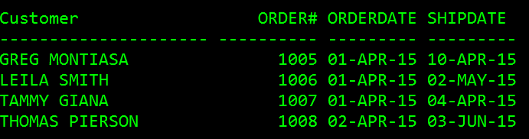

SELECT firstname || ' '|| lastname AS "Customer", order#, orderdate, shipdate

FROM customers c, orders o

WHERE c.customer# = o.customer#

AND orderdate LIKE “%APR-15”

ORDER BY 3;

**Practice 6:**

Generate a list of all customer names along with all books each customer has purchased,

Desire output

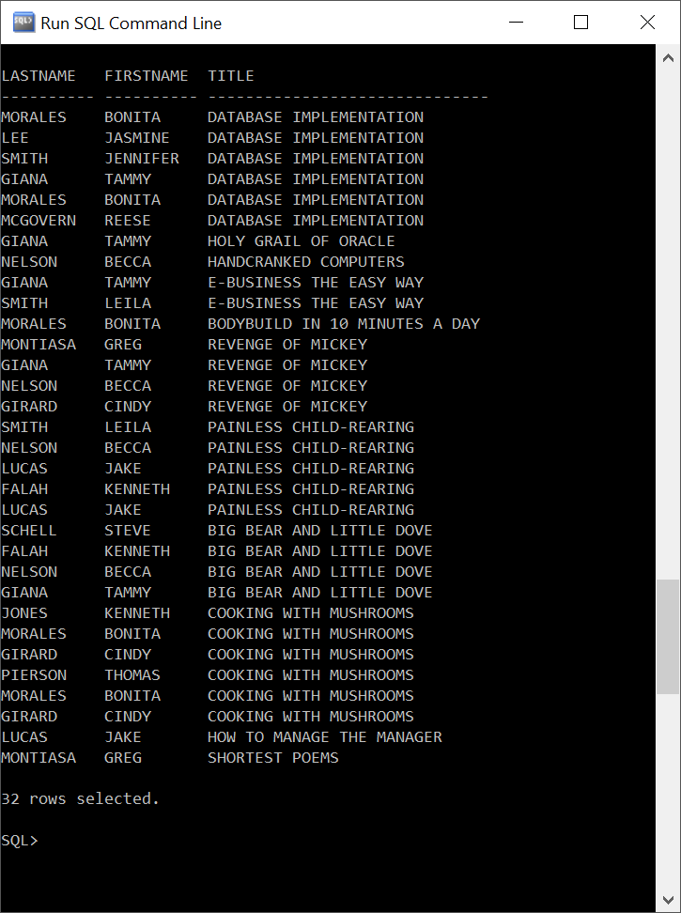

**Questions:**

**What tables are involved in the join operation?**

**Customers, orders, orderitems, books**

**How many join operations are needed? 3**

SELECT c.lastname, c.firstname, b.title

FROM customers c, orders o, orderitems oi, books b

WHERE c.customer# = o.customer#

AND o.order# = oi.order#

AND oi.isbn = b.lisbn;

**Practice 7:**

Create a list that displays customer#, order#, book title, quantity, and order date. Display only those orders that were placed in April, 2015.

Desired Output:

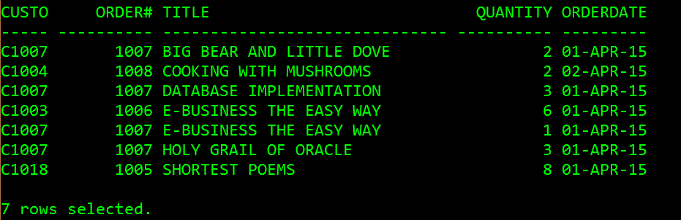

SELECT c.customer#, o.order#, title, quantity, orderdate

FROM customers c, orders o, orderitems oi, books b

WHERE c.customer# = o.customer#

AND o.order# = oi.order#

AND oi.isbn = b.lisbn

AND orderdate orderdate LIKE “%APR-15”

ORDER BY 3;